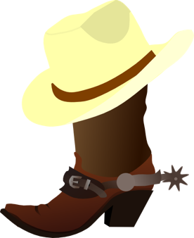

Cowboy Hustle
32 count 4 wall line dance

4- Weight on left foot. Heel down Rotate toe outwards – Out back, out back
4- Heel, heel (front) Toe, toe (back)
4. One of each Heel (front) Toe(back), Heel(front) Toe (back)
4- Step forward R, kick L Step back L, touch back R
4- Step forward R, kick L Step back L, touch back R
4- Grapevine R (step, behind step touch)
4- Grapevine L ( step, behind step ¼ turn left)
2- Step R touch
2- Step L touch

